Madhurya Mozumder

RA1911028010036

I2

EXPERIMENT -2

Aim:-  Conversion from Regular Expression to NFA

Procedure:-

The code for regular expression to NFA has been written in C language and run on a computer.

Code:-

#include<stdio.h>

#include <string.h>

int main()

{

char m[20],t[10][10];

int n, i , j , r=0, c=0;

printf("\n\t\t\t\tSIMULATION OF NFA");

printf("\n\t\t\t\t*******");

for(i=0;i<10;i++)

{

for(j=0;j<10;j++)

{

t[i][j]=' ';

}

}

printf("\n\nEnter a regular expression:");

scanf("%s",m);

n=strlen(m);

for(i=0;i<n;i++)

{

switch(m[i])

{

case '|' : {

t[r][r+1]='E';

t[r+1][r+2]=m[i-1];

t[r+2][r+5]='E';

t[r][r+3]='E';

t[r+4][r+5]='E';

t[r+3][r+4]=m[i+1];

r=r+5;

break;

}

case '*':{t[r-1][r]='E';

t[r][r+1]='E';

t[r][r+3]='E';

t[r+1][r+2]=m[i-1];

t[r+2][r+1]='E';

t[r+2][r+3]='E';

r=r+3;

break;

}

case '+': {

t[r][r+1]=m[i-1];

t[r+1][r]='E';

r=r+1;

break;

}

default:

{

if(c==0)

{

if((isalpha(m[i]))&&(isalpha(m[i+1])))

{

t[r][r+1]=m[i];

t[r+1][r+2]=m[i+1];

r=r+2;

c=1;

}

c=1;

}

else if(c==1)

{

if(isalpha(m[i+1]))

{

t[r][r+1]=m[i+1];

r=r+1;

c=2;

}

}

else

{if(isalpha(m[i+1]))

{

t[r][r+1]=m[i+1];

r=r+1;

c=3;

}

}

}

break;

}

}

printf("\n");

for(j=0;j<=r;j++)

printf(" %d",j);

printf("\n_____________\n");

printf("\n");

for(i=0;i<=r;i++)

{

for(j=0;j<=r;j++)

{

printf(" %c",t[i][j]);

}

printf(" | %d",i);

printf("\n");

}

printf("\nStart state: 0\nFinal state: %d",i-1);

}

/*input: a|b */

Output:- 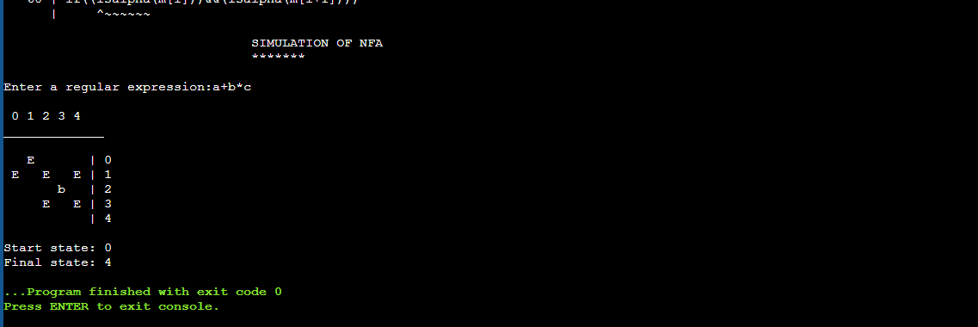

Result:-

Thus the C program to convert regular expression to NFA has been executed and the output has been verified successfully.